 Component Diagram

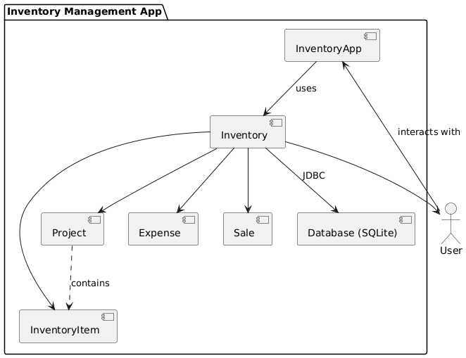

@startuml

actor User

package "Inventory Management App" {

[InventoryApp] --> [Inventory] : uses

[Inventory] --> [User]

[Inventory] --> [InventoryItem]

[Inventory] --> [Project]

[Inventory] --> [Expense]

[Inventory] --> [Sale]

[Inventory] --> [Database (SQLite)] : JDBC

[Project] ..> [InventoryItem] : contains

}

User --> [InventoryApp] : interacts with

@enduml